**Question 1: Update and Upgrade Raspberry Pi**

Command used:

1. sudo su
2. apt-get update  
   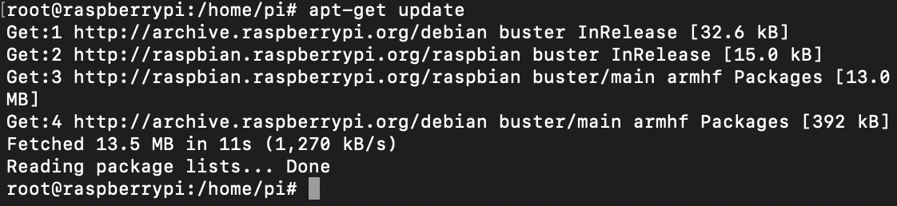
3. apt-get upgrade  
   Text

   Description automatically generated
4. y – to continue the upgrade  
   Text

   Description automatically generated
5. apt-get dist-upgrade  
   Text

   Description automatically generated

**Question 2: Install Mariadb-server and set password for the root user.**

Command Used:

1. apt install mariadb-server  
   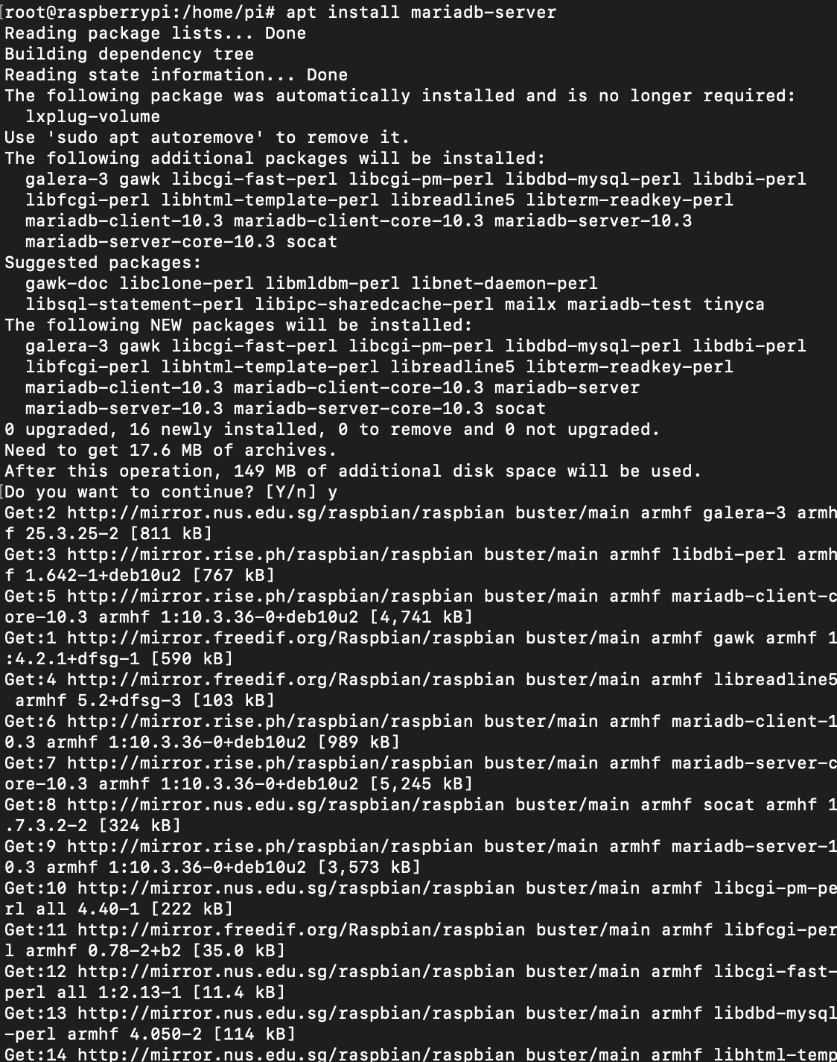  
   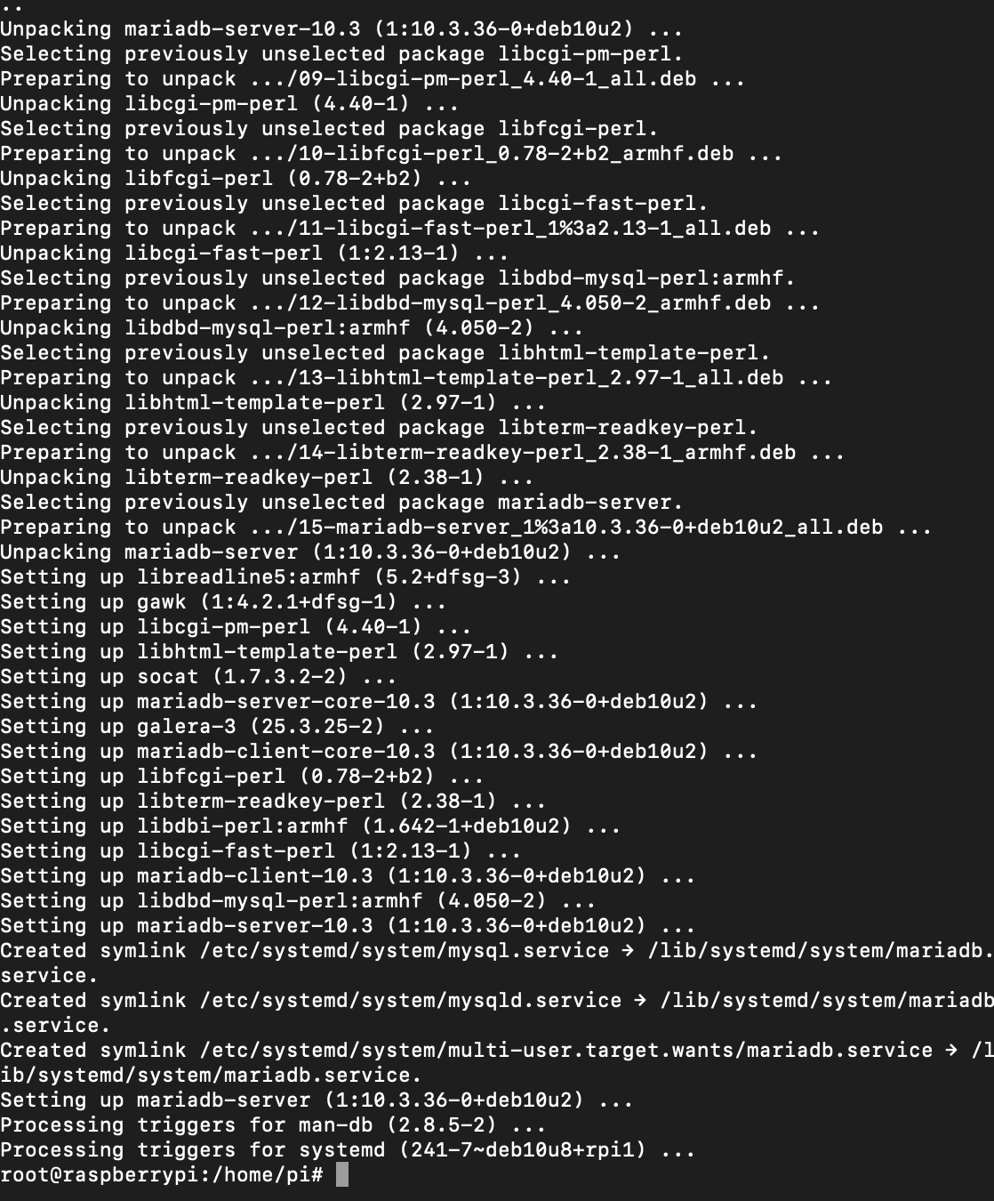
2. ALTER USER ‘root’@localhost IDENTIFIED BY ‘P@ssw0rd’  
     
   flush privileges;  
   Text

   Description automatically generated

**Question 3: Login to root user account, verify if database is installed correctly and check if password works correctly.**

Command Used:

1. sudo mysql -uroot -p123 (Entered wrong password)  
   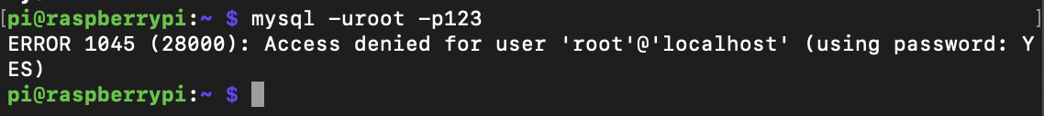
2. sudo mysql -uroot -pP@ssw0rdCorrect password)  
   Text

   Description automatically generated
3. show databases;  
   Text

   Description automatically generated with medium confidence

**Question 4: After logged in, show list of users in system using SQL**

Command Used:

1. USE mysql;  
   SELECT User FROM mysql.user;  
   Graphical user interface, text, application

   Description automatically generated

**Question 5: Show a list of existing databases**

Command Used:

1. show databases;  
   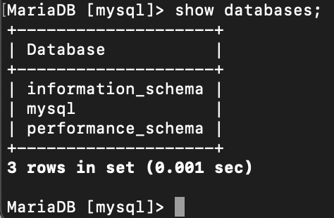

**Question 6: Create new database called  
“LauJunXiangDB”, if does not exists, otherwise, delete the existing one first then create a new one**

Command Used:

1. DROP DATABASE IF EXISTS LauJunXiangDB; CREATE DATABASE IF NOT EXISTS LauJunXiangDB;  
   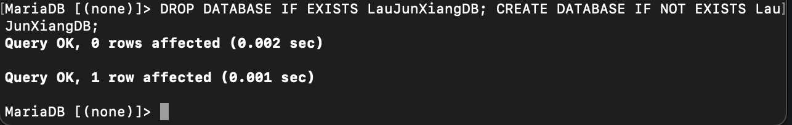
2. SHOW DATABASES;

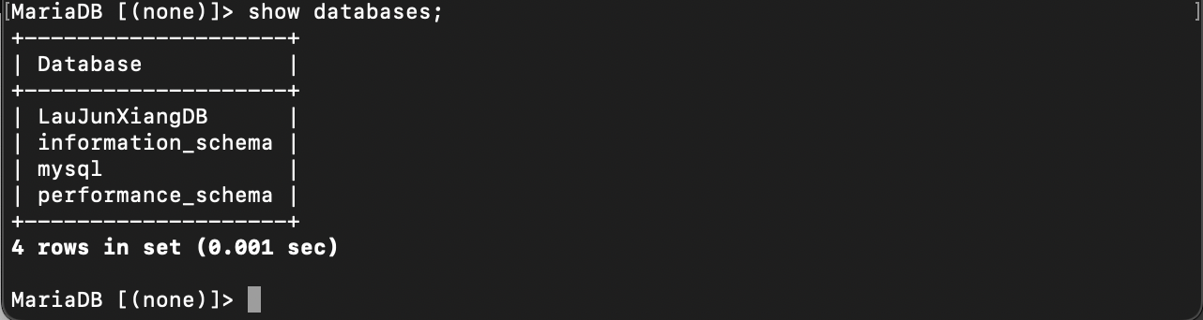

**Question 7: Create table called Students with 3 columns, sid, sname, gender. Sid = primary key.**

Command Used:

1. CREATE TABLE IF NOT EXISTS Students ( sid INT, sname VARCHAR(50) NOT NULL, gender VARCHAR(9) NOT NULL, PRIMARY KEY (sid), CHECK(gender in (“Male”, “Female”)) );  
     
   show tables;  
   Text

   Description automatically generated

**Question 8: Insert 3 students.**

Command Used:

1. INSERT INTO Students (sid, sname, gender) VALUES (1, "Lau Jun Xiang", "Male");   
     
   INSERT INTO Students (sid, sname, gender) VALUES (2, "Jeff Lee", "Male");   
     
   INSERT INTO Students (sid, sname, gender) VALUES (3, "Lim Kei Yiang", "Male");  
   Text

   Description automatically generated
2. SELECT * FROM Students;  
   Text

   Description automatically generated

**Question 9: Delete all male students**

Command Used:

1. DELETE FROM Students WHERE gender = ‘Male’;  
   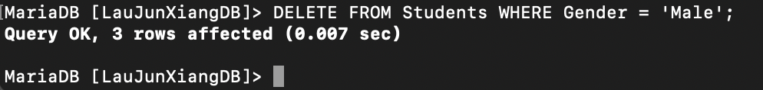
2. SELECT * FROM Students; 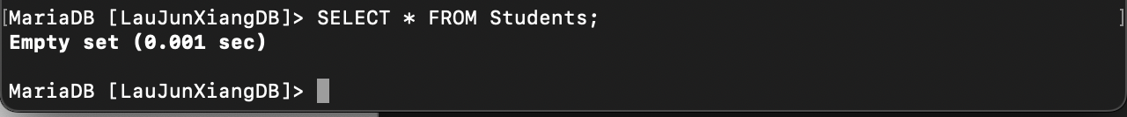

**Question 10: Delete table Students.**

Command Used:

1. DROP TABLE Students;  
   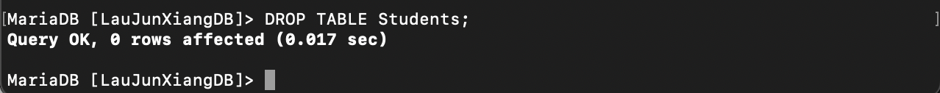
2. SHOW TABLES;  
   

**Question 11: Delete database.**

Command Used:

1. DROP DATABASE LauJunXiangDB;  
   
2. SHOW DATABASES;  
   Text

   Description automatically generated